**Objective Questions**

**1. What is the distribution of account balance across different regions?**

Based on pie chart Germany has 52.79% of distribution, France has 31.07% of distribution and Spain has 16.14% of distribution of account balance.

**2. Identify the top 5 customers with the highest Estimated Salary in the last quarter of the year. (SQL)**

Top 5 Customer name are Dyer, Oluchukwu, Mai, Palerma, Dimauro has Highest Salary in last quarter of the year.

**3.Calculate the average number of products used by customers who have a credit card. (SQL)**

The Average number of products used by customers are 1 and 2.

**4.Determine the churn rate by gender for the most recent year in the dataset.**

In 2019 churn rate for male is 273 and female is 385.

**5. Compare the average credit score of customers who have exited and those who remain. (SQL)**

The average credit score for customer exited is 645.3515 and retain customer is 651.8532.

**6. Which gender has a higher average estimated salary, and how does it relate to the number of active accounts? (SQL)**

Female has a higher average estimates salary which is 99773.2

And number of active customer are 2284.

**7. Segment the customers based on their credit score and identify the segment with the highest exit rate. (SQL)**

Highest exit rate of credit score segment is 550-650 and the number of customer is 689.

**8. Find out which geographic region has the highest number of active customers with a tenure greater than 5 years. (SQL)**

France has highest number of active customers with greater than 5 years tenure which is 797.

**9. What is the impact of having a credit card on customer churn, based on the available data?**

The customer whose has credit card churn rate is 1424.

**10. For customers who have exited, what is the most common number of products they had used?**

The most number of product used by customers whose exited is 1.

**11. Examine the trend of customer joining over time and identify any seasonal patterns (yearly or monthly). Prepare the data through SQL and then visualize it.**

Trend of Exited customers is increasing over joining over time is 2016 -376,2017-479,2018-524,2019-658. It is Rapidly increasing.

**12. Analyze the relationship between the number of products and the account balance for customers who have exited.**

Compared to other products, Product 1 has highest account

balance 129.67M customer whose are Exited.

**13. Identify any potential outliers in terms of spend among customers who have remained with the bank.**

Customer credit score 740–799(Credit worthiness – Very Good) has spending outliers in terms of customer remain in bank.

**14. Can you create a dashboard incorporating the visuals mentioned above and additionally derive more KPIs if possible?**

Created KPI in Dashboard for Churn credit card customer, sum of balance, average balance, min estimated salary, average salary etc.

**15. Using SQL, write a query to find out the gender wise average income of male and female in each geography id. Also rank the gender according to the average value. (SQL)**

In Germany Female has Highest Average income which is 102446.424 value and rank position 1 next is spain female is second Highest average which is 100734.107 and rank position is 2 and so on. Hence Female has Highest Average in among the Geographylocation.

**16. Using SQL, write a query to find out the average tenure of the people who have exited in each age bracket (18-30, 30-50, 50+).**

Age bracket 30-50 has a highest average tenure which is 4.88

and 50+ has 4.83 and 18-30 has 4.77.

**17. Is there any direct correlation between salary and balance of the customers? And is it different for people who have exited or not?**

Customer exit has direct correlation between salary and balance because both two variables has same range of value.

**18. Is there any correlation between salary and Credit score of customers**

credit score range 300-850 has no correlation between salary and credit score of customers.

**19. Rank each bucket of credit score as per the number of customers who have churned the bank.**

Rank each segment Credit score whose exited are first rank 550-650 number of customers exited 689,second rank is 650-750 number of customers exited is 667,third rank 750-850 number of customers exited is 313,fourth rank 450-550 number of customers exited is 307,fifth rank 350-450 number of customers exited is 61.

**20. According to the age buckets find the number of customers who have a credit card. Also retrieve those buckets who have lesser than average number of credit cards per bucket.**

Age bracket of 30-50 number of customers are 4781, 18-30 age brackets has 1400 number of customers, 50+ age brackets has 874.

**21. Rank the Locations as per the number of people who have churned the bank and average balance of the learners.**

Germany has first rank highest average has 120361.07 and exited customer is 814, France has second rank average is 71192.79 and exited customer is 810, Spain has third rank average is 72513.35 and exited customer is 413.

**Subjective Questions : -**

1. **Customer Behavior Analysis: What patterns can be observed in the spending habits of long-term customers compared to new customers, and what might these patterns suggest about customer loyalty**

New customers joined at bank in 2019 spend High compared to Long term customers show in below graph

1. **Product Affinity Study: Which bank products or services are most commonly used together, and how might this influence cross-selling strategies?**

Porduct number 1 is most used bank product customer commonly used together

1. **Geographic Market Trends: How do economic indicators in different geographic regions correlate with the number of active accounts and customer churn rates?**

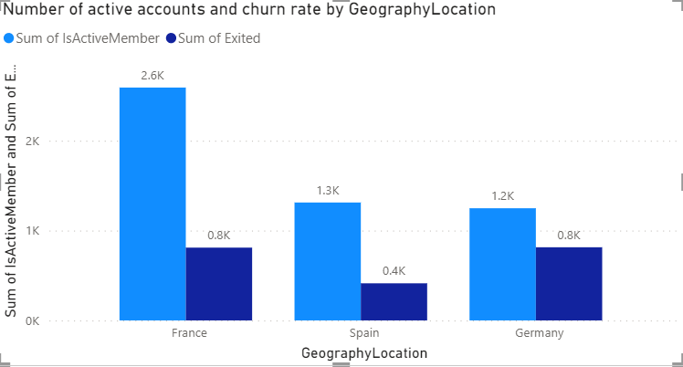

In France has Highest active accounts and churn rates and Spain has lowest churn rates among the Geography Location.

1. **Risk Management Assessment: Based on customer profiles, which demographic segments appear to pose the highest financial risk to the bank, and why?**

Customer churn from has high in the age bracket of 30-50. This age bracket churn rate lead to high financial risk for bank.

1. **Customer Lifetime Value Forecast: How would you use the available data to model and predict the lifetime value of different customer segments?**

Based on Above chart Fair customer which is customer segment 580–669 has lifetime value customer in the segment.

1. **Marketing Campaign Effectiveness: How could you assess the impact of marketing campaigns on customer retention and acquisition within the dataset?**

Number of customers Retain in Highest in the recent year 2019 which is 2655 compared to the previous years.

1. **Customer Exit Reasons Exploration: Can you identify common characteristics or trends among customers who have exited that could explain their reasons for leaving?**

Based on the above data the correlation between salary and balance is high in retain customer. But Exit customer has equal range of salary and balance. If the have high salary and balance means they will not exit bank.

1. **Are 'Tenure', 'NumOfProducts', 'IsActiveMember', and 'EstimatedSalary' important for predicting if a customer will leave the bank?**

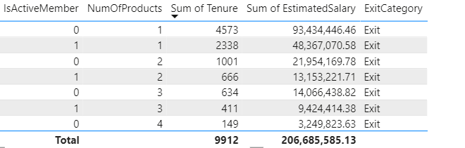

All Tenure, Number of product, active members, estimated salary all related to each other.

1. **Utilize SQL queries to segment customers based on demographics, account details, and transaction behaviors.**

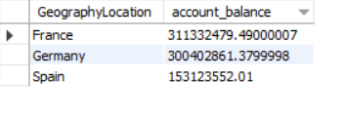

France has Highest account balance among the Geographic region.

**10. How can we create a conditional formatting setup to visually highlight customers at risk of churn and to evaluate the impact of credit card rewards on customer retention?**

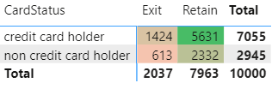

**11. What is the current churn rate per year and overall as well in the bank. Can you suggest some insights to the bank about which kind of customers are more likely to churn and what are the different strategies that can be used to decrease the churn rate.**

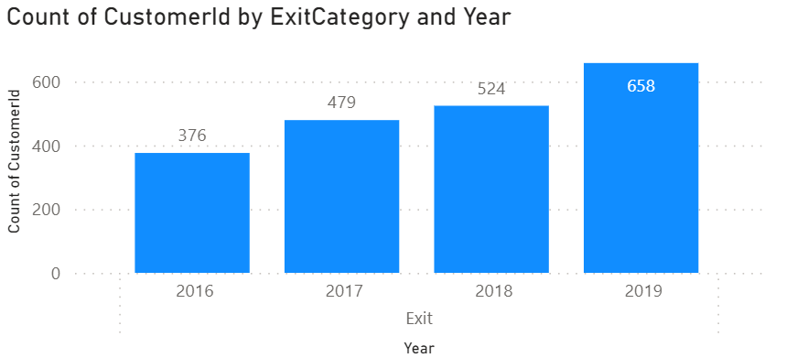

Last year churn rate is 658 which is in 2019. If the correlation between balance and salary high then exit customer will be low.